Section 3.6: Quantified Statements
We are now prepared to use our tools for working with sets to work with statements like “all frogs are green” or “no bears are funny,” which we would like to use in arguments.

Quantified Statements
Definition: Quantified Statements
A quantified statement is a statement about all or some members of a group.
In other words, it is a statement about all or some elements of a set.
The following are examples of quantified statements:
- All runners are athletes.
- Some dogs have fleas.
- Some doctors do not play golf.
- No math teachers are funny.
Quantified statements tell us that ___________ or ___________ of the elements of a ___________ are or are not in another ___________. To help us understand—and ultimately symbolize—quantified statements, we will use Venn diagrams as well as another kind of diagram, an Euler diagram.
Definition: Euler Diagram
An Euler diagram (pronounced oiler) is a diagram similar to a Venn diagram, but in which subsets that are known to be empty are removed.
We will build Euler diagrams based on various Venn diagrams throughout this section.

Universal Statements
Definition: Universal Statement
A universal statement tells us something about of the elements of a set.
A positive universal tells us that all the elements of a set belong to another set.
A negative universal tells us that all the elements of a set belong to
another set; in other words, ________ of the elements of one set also belong to another.
Example The statement below is a universal statement.
All cats are quick.
If we define the sets:
$C=$ the set of all ____________________
$Q=$ the set of all ____________________
we get the following Venn diagram, where the shaded region indicates a set that we know is empty.
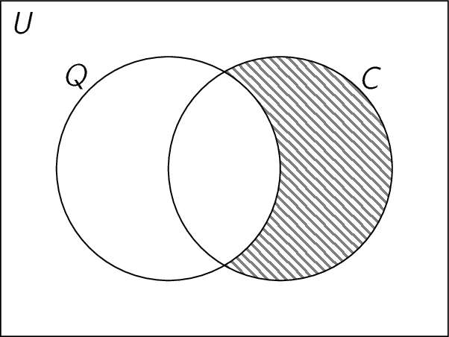
To convert this to an Euler diagram, we follow two steps:
- Stop drawing the universal set (it’s assumed in an Euler diagram).
- Delete the parts that are known to be empty.
- Redraw so that each set is represented by a circle.
For this Euler diagram, here is the process.
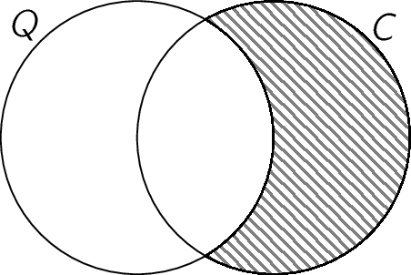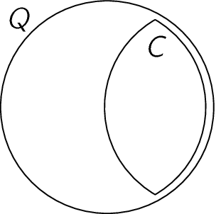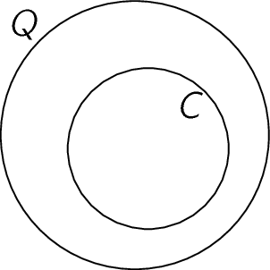
We will think of the Euler diagram (the last one in the sequence) as representing the statement “All cats are quick.” Notice that the set of cats is the set
of quick things—in other words, cats are a of quick things.

Example The statement below is a universal statement.
No birds are fish.
If we define the sets:
$B=$ the set of all ____________________
$F=$ the set of all ____________________
we get the following Venn diagram, where the shaded region indicates a set that we know is empty.
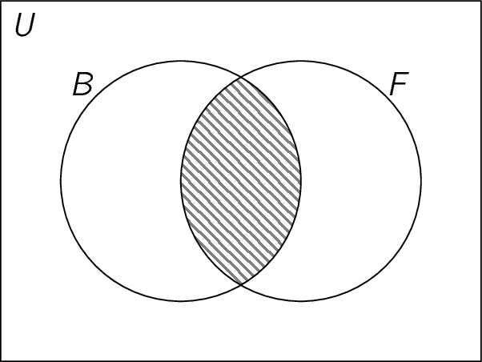
We can follow the same steps as before to convert this to an Euler diagram.
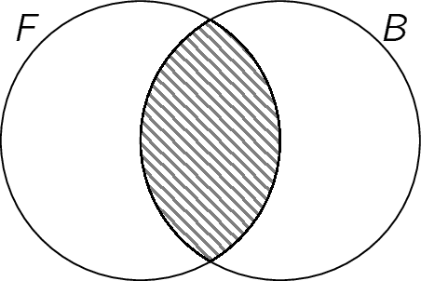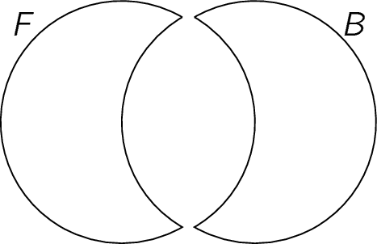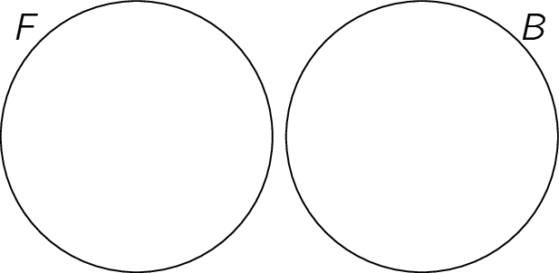
We will think of the Euler diagram (the last one in the sequence) as representing the statement “No birds are fish.” Notice that the set of birds and the set of fish do not
_________________________—in other words, the sets are .

Existential Statements
Definition: Existential Statement
An existential statement tells us something about of the elements of a set.
A positive existential tells us that an element of one set belong to another set.
A negative universal tells us that an element of one set belong to
another set.
We use the word “some” when we make an existential statement. Note that, when we’re speaking formally, “some” means “at least one.” In particular:
- “Some” does not mean
- “Some” does not mean
(that is, for example, “some frogs are green” and “all frogs are green” can _____________ be true).
Example The statement below is a existential statement.
Some people can sing
If we define the sets:
$P=$ the set of all ____________________
$S=$ the set of all ____________________
then we can draw the Venn diagram below:
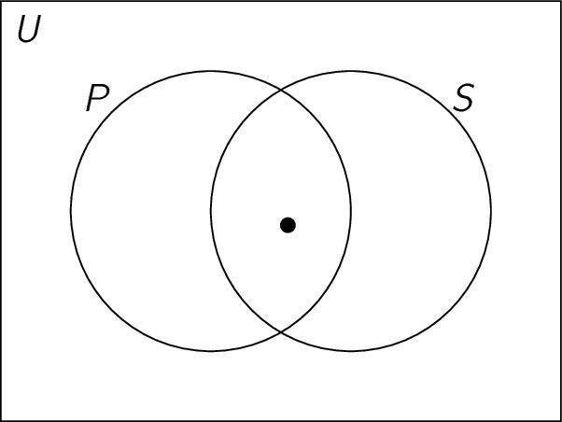
The dot represents the fact that there must be something in the overlap between the two circles.

Example The statement below is a existential statement.
Some math teachers are not funny.
If we define the sets:
$M=$ the set of all ____________________
$F=$ the set of all ____________________
then we can draw the Venn diagram below:
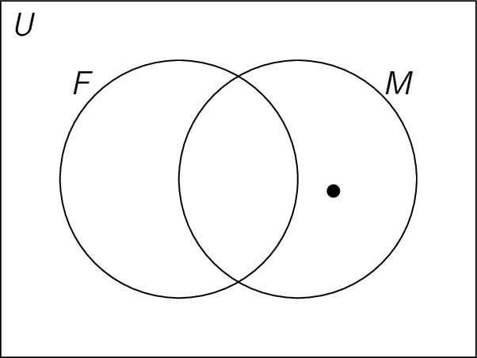
The dot represents the fact that there must be something in the overlap between the two circles.

Possible Euler Diagrams
So far, we’ve seen two possible Euler diagrams. For sets $A$ and $B$, we have seen:
- “All [set B] are [set A]”
Venn diagram Euler diagram
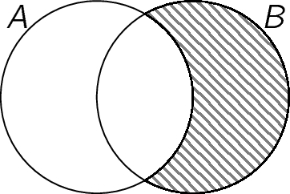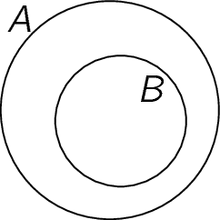
- “No [set A] are [set B]” or “No [set B] are [set A]”
Venn diagram Euler diagram
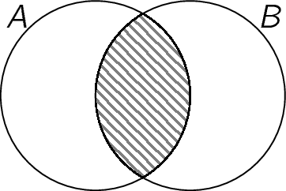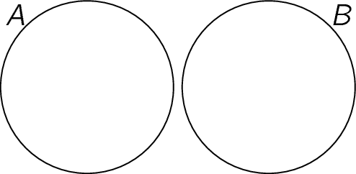
There are three other Euler diagrams that we might draw.
- “All [set A] are [set B]”
Venn diagram Euler diagram
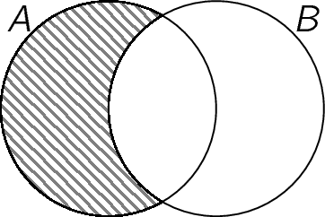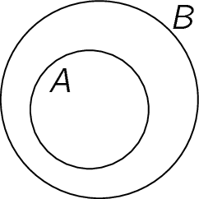
This is like the first one, but in the opposite
- “All [set A] are [set B]” and “All [set B] are [set A]” at the same time.
Venn diagram Euler diagram
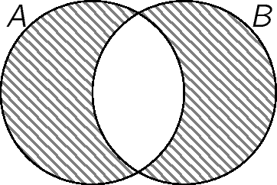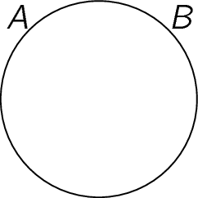
Here, the two sets are the ____________ set, so they’re the same .
- The last one is the default diagram, with all possible overlaps. So there are some things that are in both sets, some that are only in A, some that are only in B.
Venn diagram Euler diagram
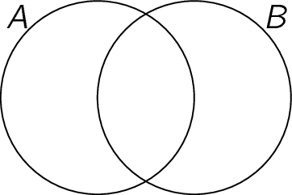

Negations of Quantified Statements
Let’s consider how to negate a quantified statement.
Example Negate the statement below.
All trees are tall.
If we define the sets:
$R=$ the set of all ____________________
$L=$ the set of all ____________________
We’ll use the Venn diagram below to think through the negation.
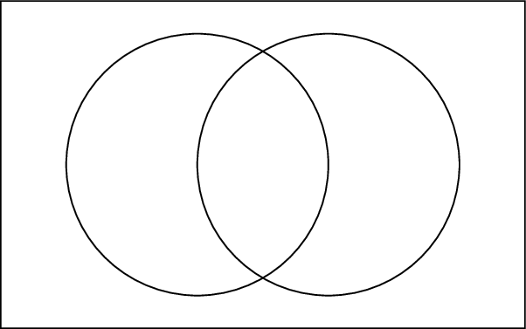
- When the statement is true,

- So when the statement is false (that is, if the negation is true),

The negation of “All trees are tall.” is

Example Negate the statement below.
Some artists use oil paints.
If we define the sets:
$A=$ the set of all ____________________
$O=$ the set of all ____________________

The negation of “Some artists use oil paints” is

You do not need to memorize how to negate a quantified statement! Instead, draw (or imagine) the Venn diagram, and think through what the negation must be.

Symbolizing a Positive Universal
In the context of an argument, we will be applying a universal statement to a _________________________________.
Example In the argument below, how could you symbolize the universal statement?
All runners are athletes. Lydia is a runner. Therefore, Lydia is an athlete.
This argument has two premises and a conclusion.
Premise 1:
Premise 2:
Conclusion:
To symbolize premise _____ and the conclusion, we need two simple statements:
$p=$
$q=$
We hope that we can symbolize premise _____ in terms of these two simple statements, too. To do this, we’ll use both a truth table and a Venn diagram!

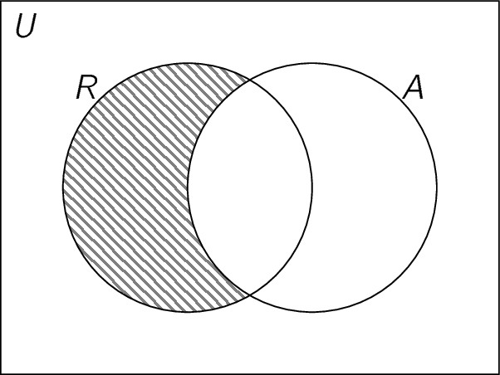
Row | $$p$$ | $$q$$
1 | T | T
2 | T | F
3 | F | T
4 | F | F

Looking at the for rows of the truth table, this is what we see.
- $p=T$ and $q=T$, so

This ( can | can’t ) be true if “all runners are athletes”.
- $p=T$ and $q=F$, so

This ( can | can’t ) be true if “all runners are athletes”.
- $p=F$ and $q=T$, so

This ( can | can’t ) be true if “all runners are athletes”.
- $p=F$ and $q=F$, so

This ( can | can’t ) be true if “all runners are athletes”.
Only row _____ can’t be true all runners are athletes; this is
We’ll use a to symbolize a positive universal.

Symbolizing a Negative Universal
Example In the argument below, how could you symbolize the universal statement?
No math teachers are nice. Bob is a math teacher. Therefore, Bob is not nice.
This argument has two premises and a conclusion.
Premise 1:
Premise 2:
Conclusion:
To symbolize premise _____ and the conclusion, we need two simple statements:
$p=$
$q=$
We hope that we can symbolize premise _____ in terms of these two simple statements, too. To do this, we’ll use both a truth table and a Venn diagram!

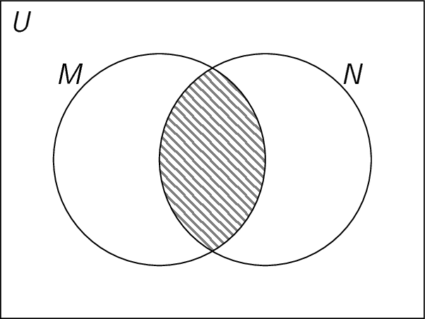
Row | $$p$$ | $$q$$
1 | T | T
2 | T | F
3 | F | T
4 | F | F

Looking at the for rows of the truth table, this is what we see.
- $p=T$ and $q=T$, so

This ( can | can’t ) be true if “no math teachers are nice”.
- $p=T$ and $q=F$, so

This ( can | can’t ) be true if “no math teachers are nice”.
- $p=F$ and $q=T$, so

This ( can | can’t ) be true if “no math teachers are nice”.
- $p=F$ and $q=F$, so

This ( can | can’t ) be true if “no math teachers are nice”.
Only row _____ can’t be true all runners are athletes; we haven’t seen this truth table before!

We’re trying to symbolize a truth table with _____ “true” rows. Since order doesn’t matter, we’ll try to use __________________.
$$p$$ | $$q$$ | Goal | $$\sim p$$ | $$\sim q$$ | $$p∨q$$ | $$\sim p∨q$$ | $$p∨\sim q$$ | $$\sim p∨\sim q$$
The statement we’re trying to symbolize is ________________.
We’ll use a with ______________ to symbolize a negative universal.

